IEEE SMC 2020 Conference Report

The 2020 IEEE International Conference on Systems, Man, and Cybernetics (SMC 2020) is the flagship conference of the IEEE Systems, Man, and Cybernetics Society. Due to the COVID19 pandemic, SMC 2020 will be held as a virtual event. Despite the challenges, the SMC 2020 Organizing Committee and volunteers worked very hard to complete the conference program, uphold the quality of conferences, and meet authors’ expectations. This year’s technical program covers the three technical areas of the Systems, Man, and Cybernetics Society and will explore research innovation and industrial applications. We look forward to welcoming you to SMC 2020.
Each year the SMC Conference has a different theme. The main theme this year is Human-Centered Systems for Smart and Connected Communities and Infrastructures, which stimulates research, innovations, and technology implementations promoting connected communities. The conference also offers an excellent opportunity to exchange new results and challenges. Topics include current information and communication technologies, the Internet of Things, big data, cloud computing, and innovative and promising applications in automation and process management. Emerging application fields such as logistics, intermodal transportation systems, sustainable healthcare systems, and green automation are also included.
This year the conference received 1,116 submissions including regular and special session papers. The IEEE SMC Program Committee performed a rigorous peer review process and accepted 689 papers from 34 countries to appear in the conference proceedings organized in 148 regular and special sessions.
The conference program begins on Sunday, October 11, 2020 with three tutorials and four workshops. The 4-day program includes three keynote talks and three panel sessions. Prof. Larry Hall will deliver a keynote talk on “Explorations in BIG Data and sMall Data with Deep Learning”, Prof. Nadia Magnenat Thalmann will address the question of “Humanoid Social Robots: What’s New and What’s Next?” in her keynote, while Dr. Grady Booch will answer the question “What Does it Mean to be Human?”. The three panels are a Joint INCOSE/SMCS Panel on The Future of Systems Engineering, the IEEE SMC Society Founders’ Forum, and the SMC Women in Engineering and Young Professionals that will host its traditional luncheon event virtually this year. Following the tradition of past IEEE SMC conferences, two sessions are devoted to the presentation of candidates for the Best Student Paper Award and the Best Conference Paper Award.
As part of the program, SMC 2020 will also host the 10th Workshop on Brain-Machine Interface (BMI) Systems Workshop featuring regular and special sessions. The Workshop provides a forum to present research results and facilitate the interaction and intellectual exchange between researchers, developers, and consumers of BMI technology. Furthermore, a Brain Computer-Interface Hackathon will be held October 11-12, 2020.
We thank the Program Co-Chairs Kazuo Kiguchi, Vladimir Marik, and Andreas Nürnberger; the Technical Program Co-Chairs Maria Pia Fanti, Feiqi Deng, Yo-Ping Huang, Shun-Feng Su, Saeid Nahavandi, Honghai Liu, Naoyuki Kubota, and Koji Murai; the Special Sessions Co-Chairs Robert Kozma, Hideyuki Takagi, and Enrique Herrera Viedma; the Tutorial Chair Sam Kwong; the Workshop Co-Chairs Chris Nemeth and Abdulmotaleb El Saddik; Junior Co-Chairs György Eigner and Ana Laura Gonzalez Rios; the Associate Editors, and the Reviewers for their valuable contributions to the paper selection process and for maintaining the high quality of the conference publications.
Our special thanks go to BMI Workshop Honorary Chair Michael H. Smith and Co-Chairs Tiago H. Falk and Christoph Guger for organizing the 10th BMI Workshop and the br41n.io Brain-Computer Interface Hackathon.
We thank the Organizing Committee Members and the Conference Treasurer Vladik Kerinovich for invaluable support in organizing the conference. We also thank Michael H. Smith, Lawrence Hall, and Philip Chen for serving as Awards Co-Chairs. We acknowledge the support of the Systems, Man, and Cybernetics Society in transitioning the conference to a virtual event. We would also like to thank the Conference Secretary Chiagoro Ahaotu and Webmaster Md Rafiul Abdussami for their dedication, service, and help in creating this successful event. This virtual event was organized and technically supported by IEEE Meetings, Conferences & Events. Finally, we would like to thank the keynote and panel speakers, tutorial and workshop organizers, session chairs and co-chairs, and the authors and presenters of submitted and accepted papers for making this event a success.
Stay safe and healthy!

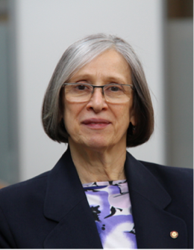
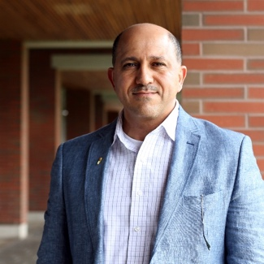

General Chair, Hossam A. Gabbar General Co-Chair, Ljiljana Trajkovic

